**Date: 21/09/2020**

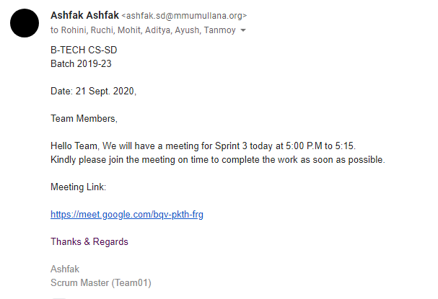

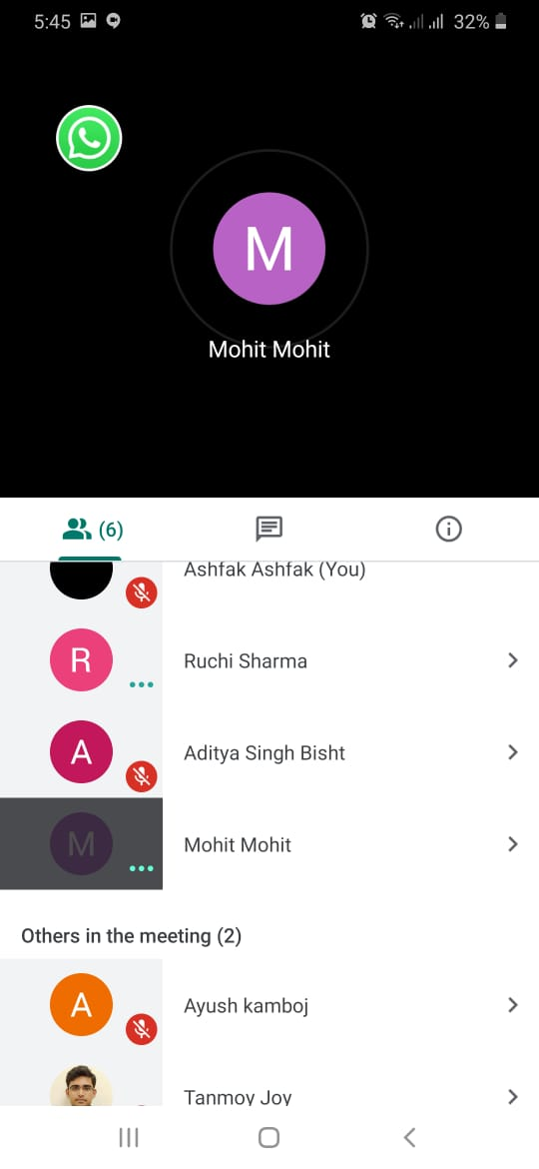

**Minutes of meetings:**

1. Roles re assigned
2. Sprint backlog for sprint 3 finalized
3. Sprint duration finalized

**Date: 22/09/2020**

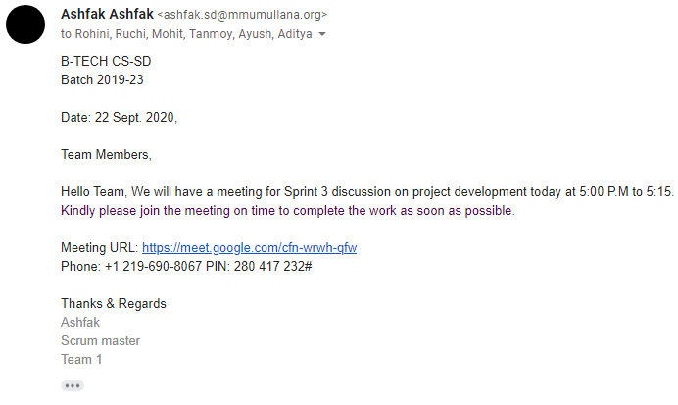

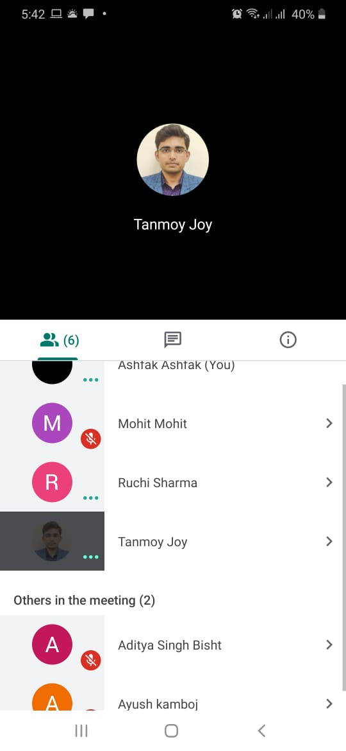

**Minutes of meetings:**

1. Calculator workings, input/output and the lay out were discussed
2. Finalized the calculator page

**Date: 23/09/2020**

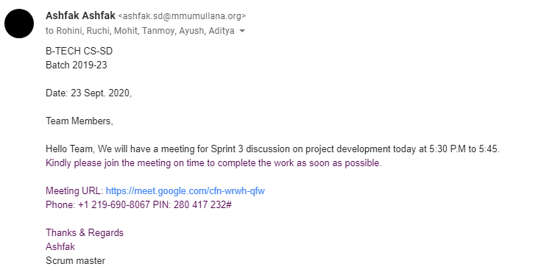

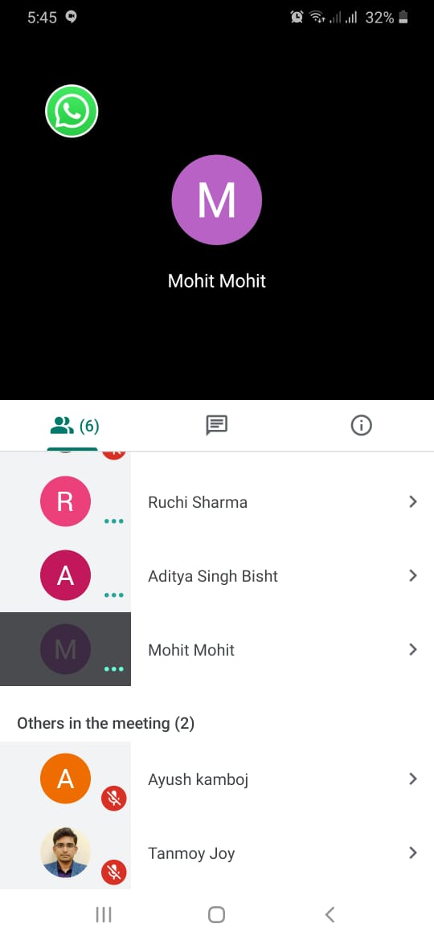

**Minutes of meetings:**

1. Had a short discussion on all the defects on the sprint 2 presentation
2. Project detail page completed and reviewed

**Date: 24/09/2020**

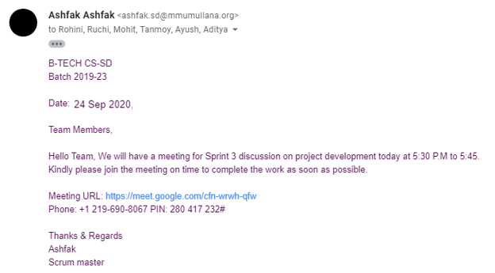

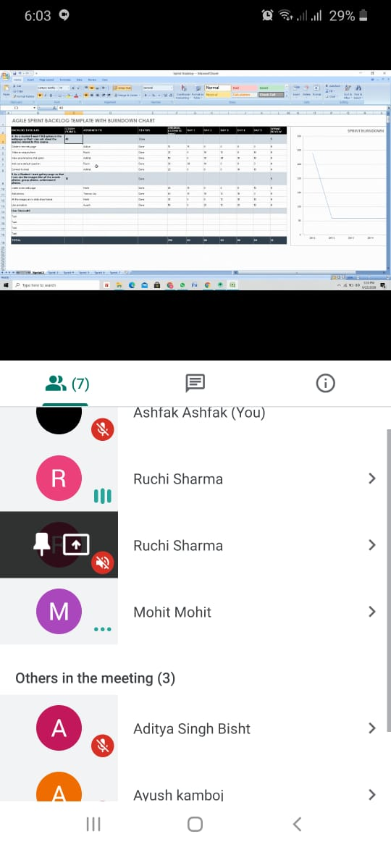

**Minutes of meetings:**

1. Decided to add a sprint and bring changes to all the UI and wireframe
2. Manager’s advice were followed and all the current sprint task were completed and reviewed

**Date: 25/09/2020**

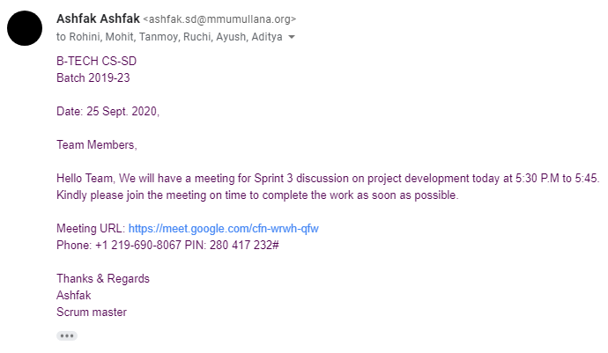

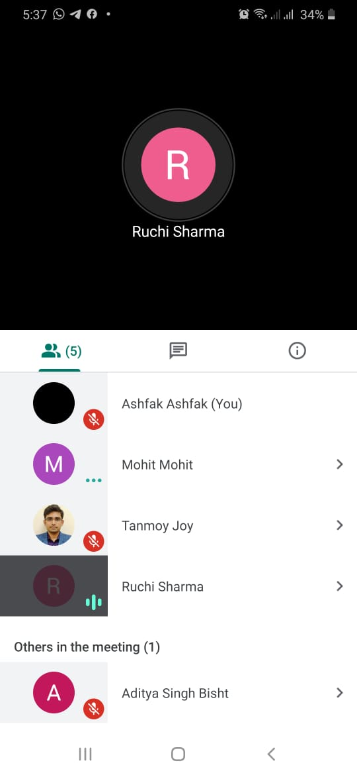

**Minutes of meetings:**

1. Ended sprint 3
2. Made list of all the mistakes mentioned in the scrum meeting with the faculty
3. Tester presented the test reports